TASK 3: Attach and Detach Disk from Windows VM

Objective
To attach a new data disk to an existing Windows Virtual Machine, initialize and format the disk, assign a drive letter, and then detach the disk from the VM.

Theory
An Azure Data Disk is an additional managed disk that can be attached to a Virtual Machine to increase storage capacity. Data disks are commonly used to store application data, databases, logs, and user files separately from the operating system disk. Azure allows administrators to attach, initialize, use, and detach disks as required without affecting the operating system.

Procedure

Step 1: Open Virtual Machine
Navigate to Azure Portal → Virtual Machines and select the target Windows VM.
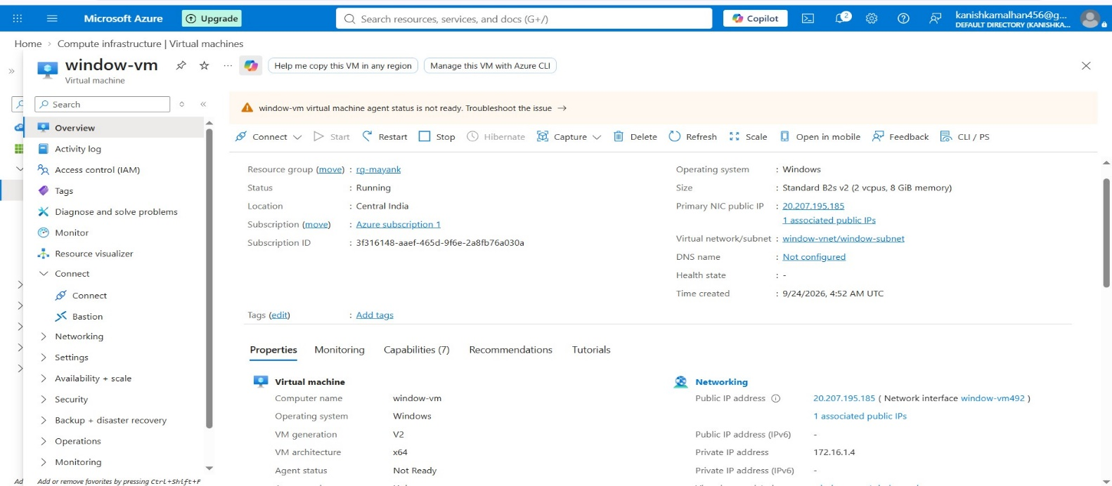

Step 2: Connect to the Windows VM
Connect to the VM using Remote Desktop Protocol (RDP).
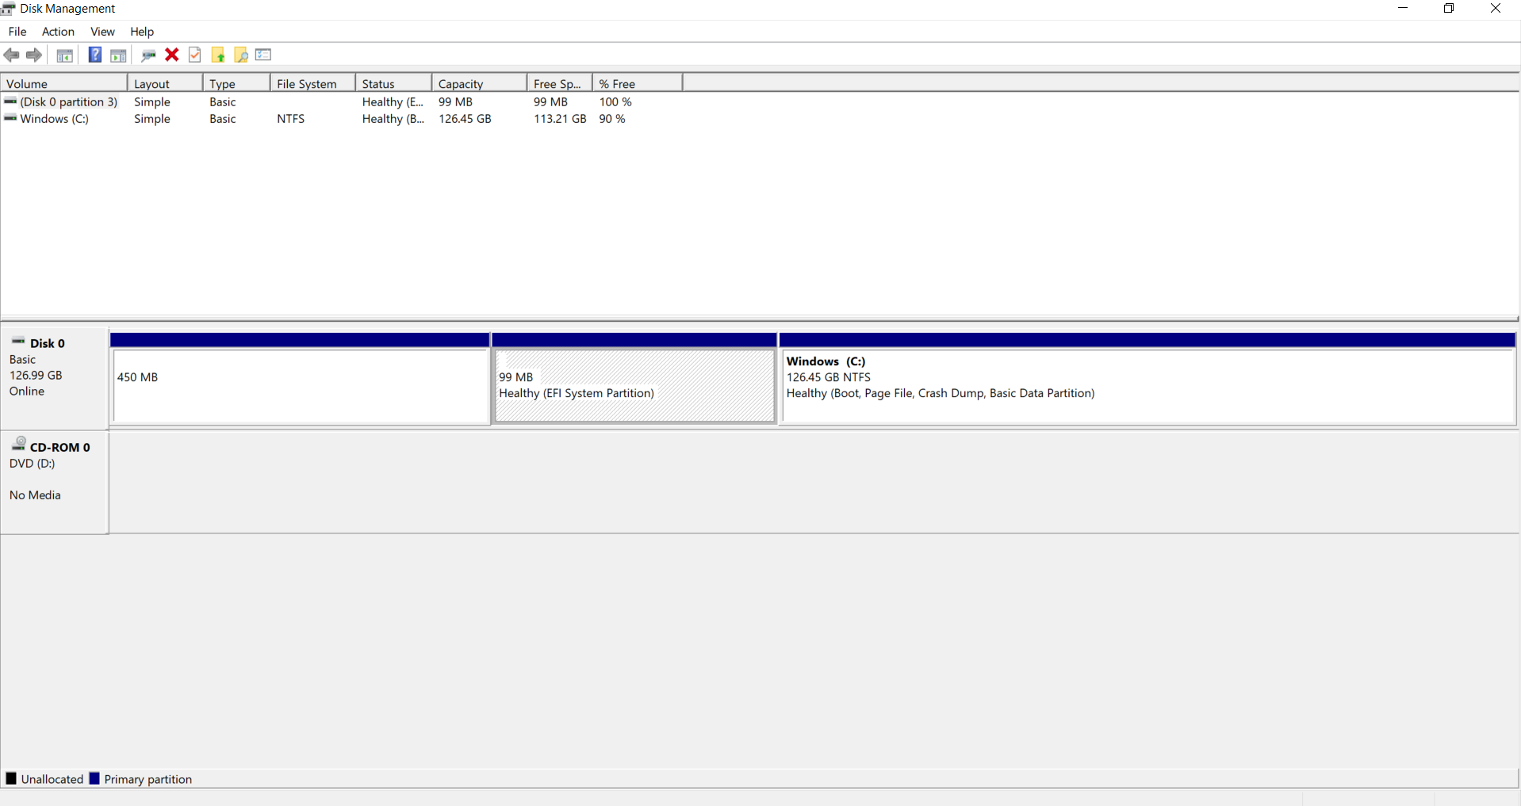

Step 3: Open Disks Blade
Disks Configuration Page , From the left menu, click Disks.
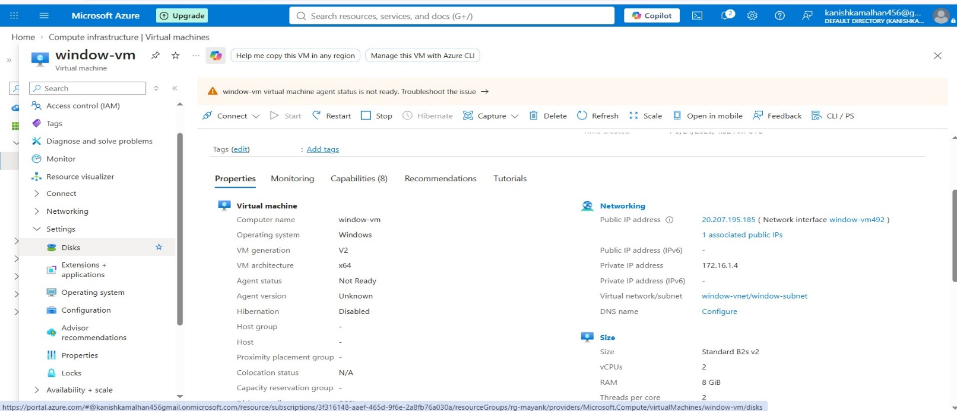

Step 4: Create and Attach New Disk
Click Create and attach a new disk.
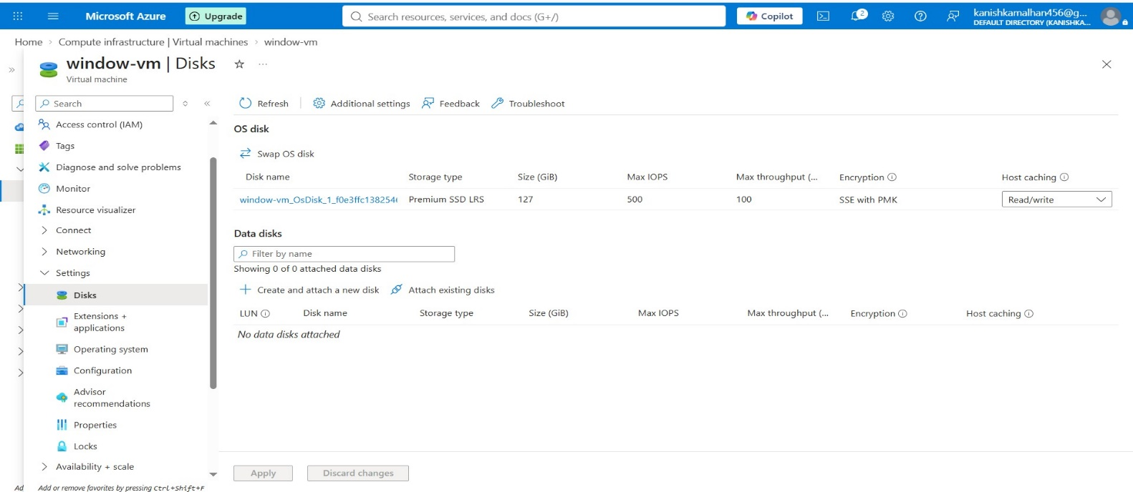

Step 5: Configure Disk Details
Enter the disk name and select the required disk size.
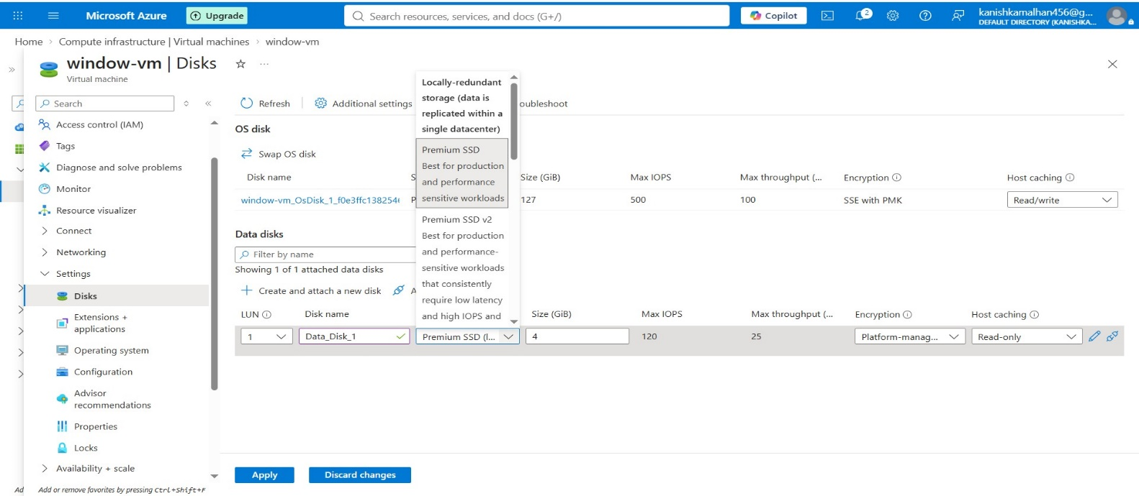

Step 6: Attach the Disk
Click Apply/Save to attach the new disk to the VM. Disk Attached Successfully
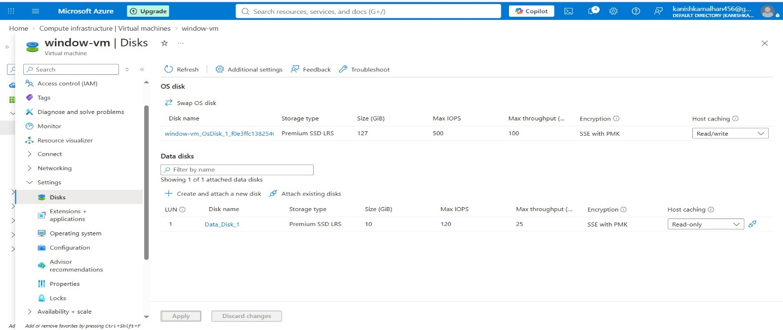

Step 7: Open Disk Management
Open Disk Management from Server Manager or Run → diskmgmt.msc. Disk Management Showing Newly Attached Disk
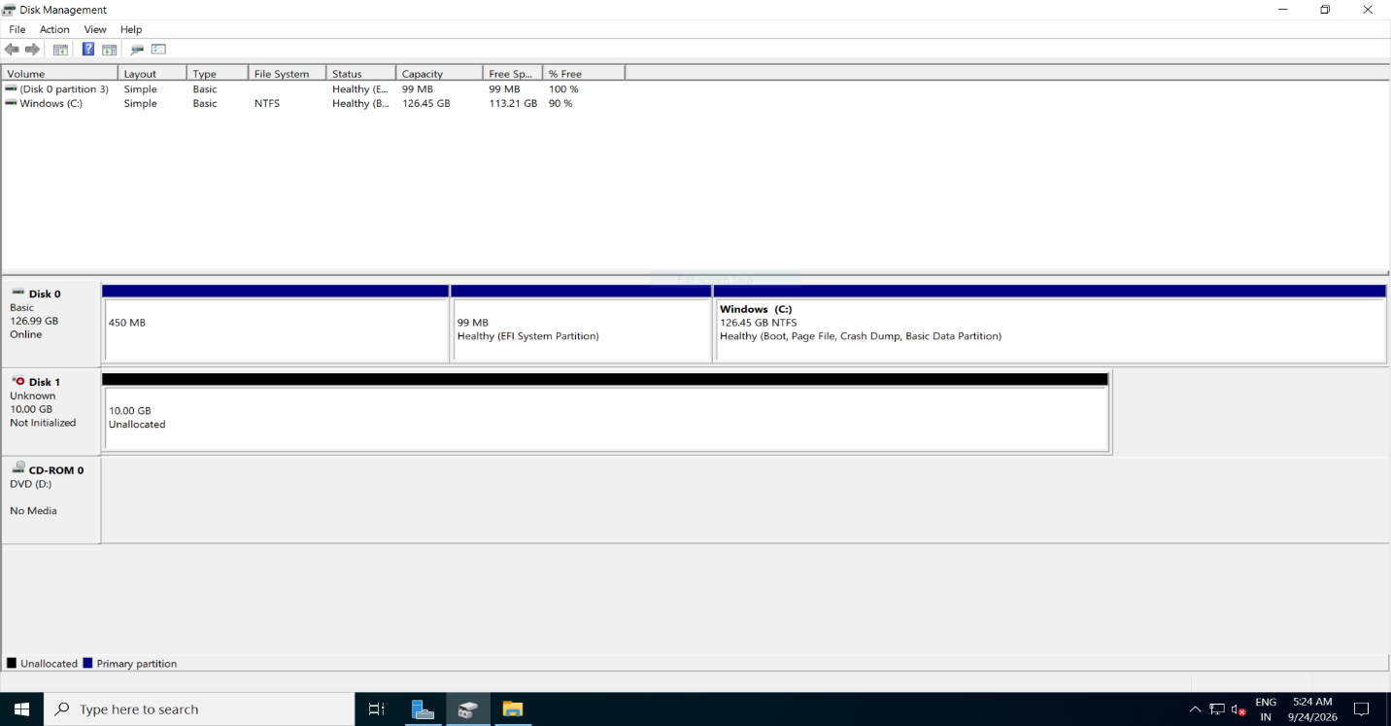
Step 8: Initialize the Disk
Right-click the new disk and select Initialize Disk. Choose GPT (GUID Partition Table).
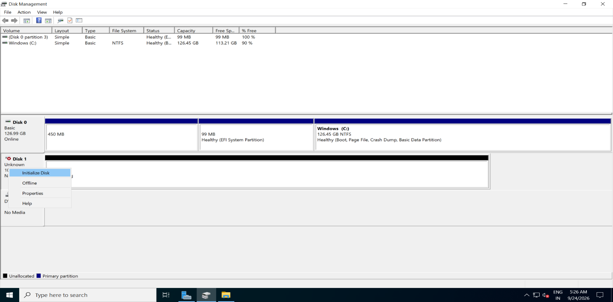

Step 9: Create New Simple Volume
Right-click the unallocated space and select New Simple Volume.
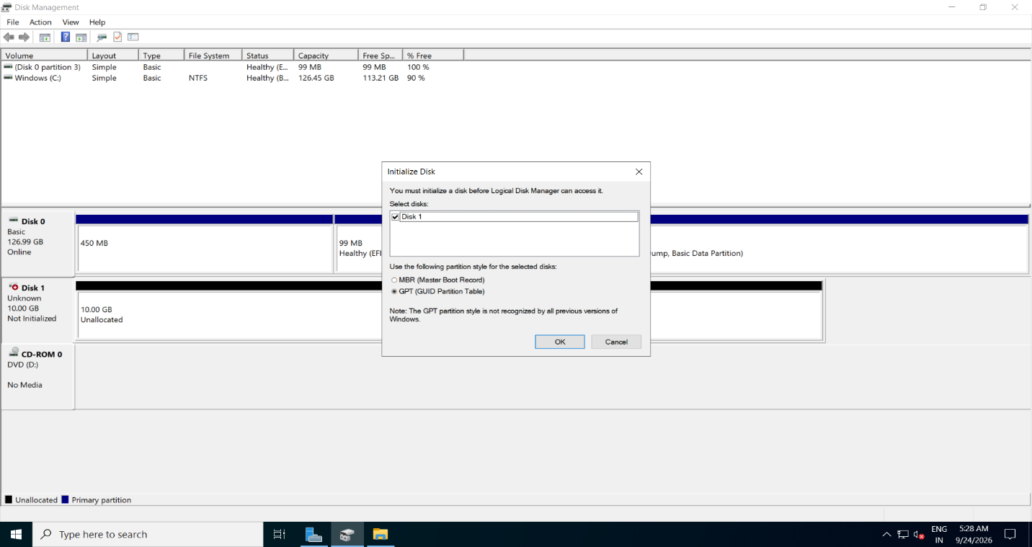

Step 10: Assign Drive Letter and Mount the Volume
Assign the drive letter (E:) to the new volume.
Note: After assigning the drive letter, Windows automatically mounts the volume and makes it accessible through File Explorer.
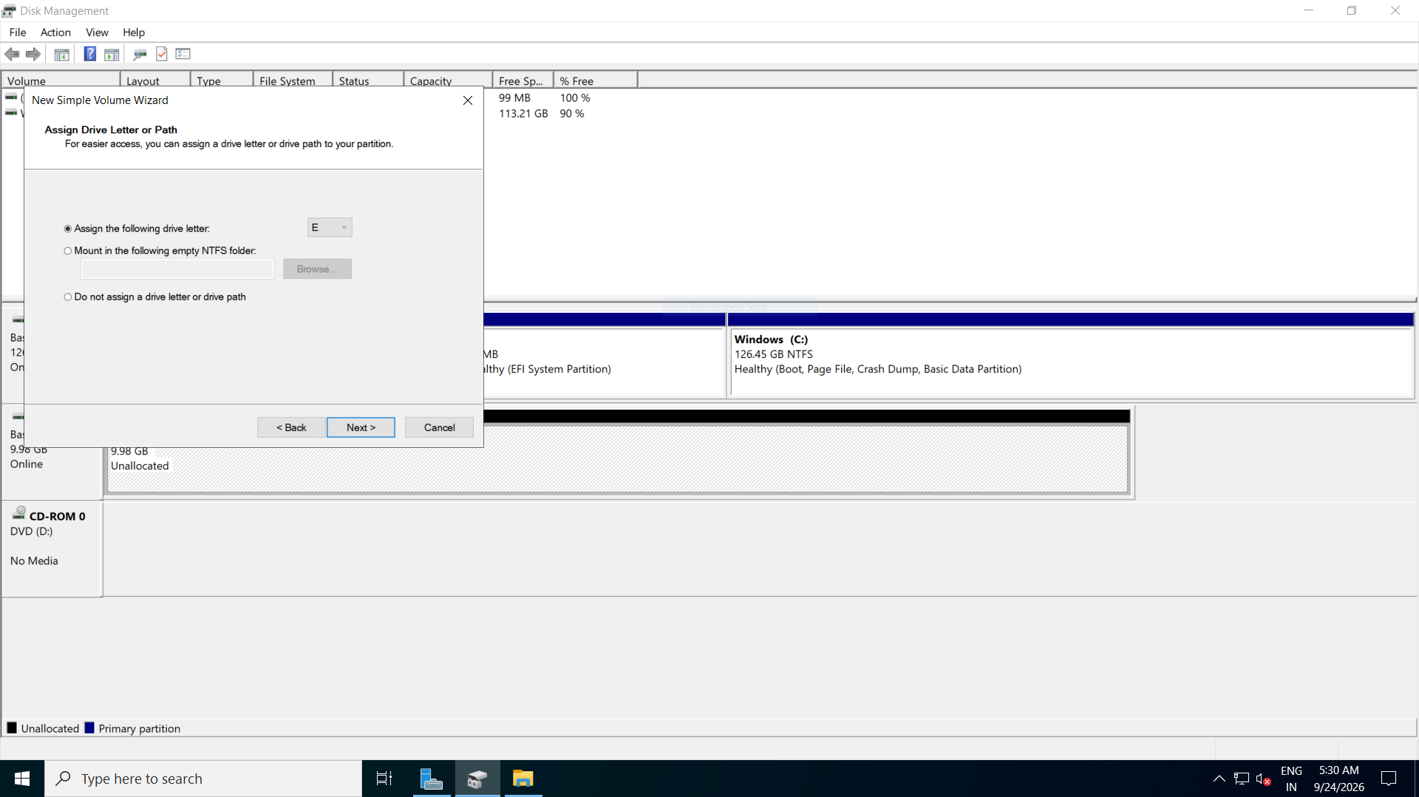
Step 11: Verify Disk Availability
Confirm that the new E: drive is visible and healthy. Attached Disk (E:) Visible in Disk Management.
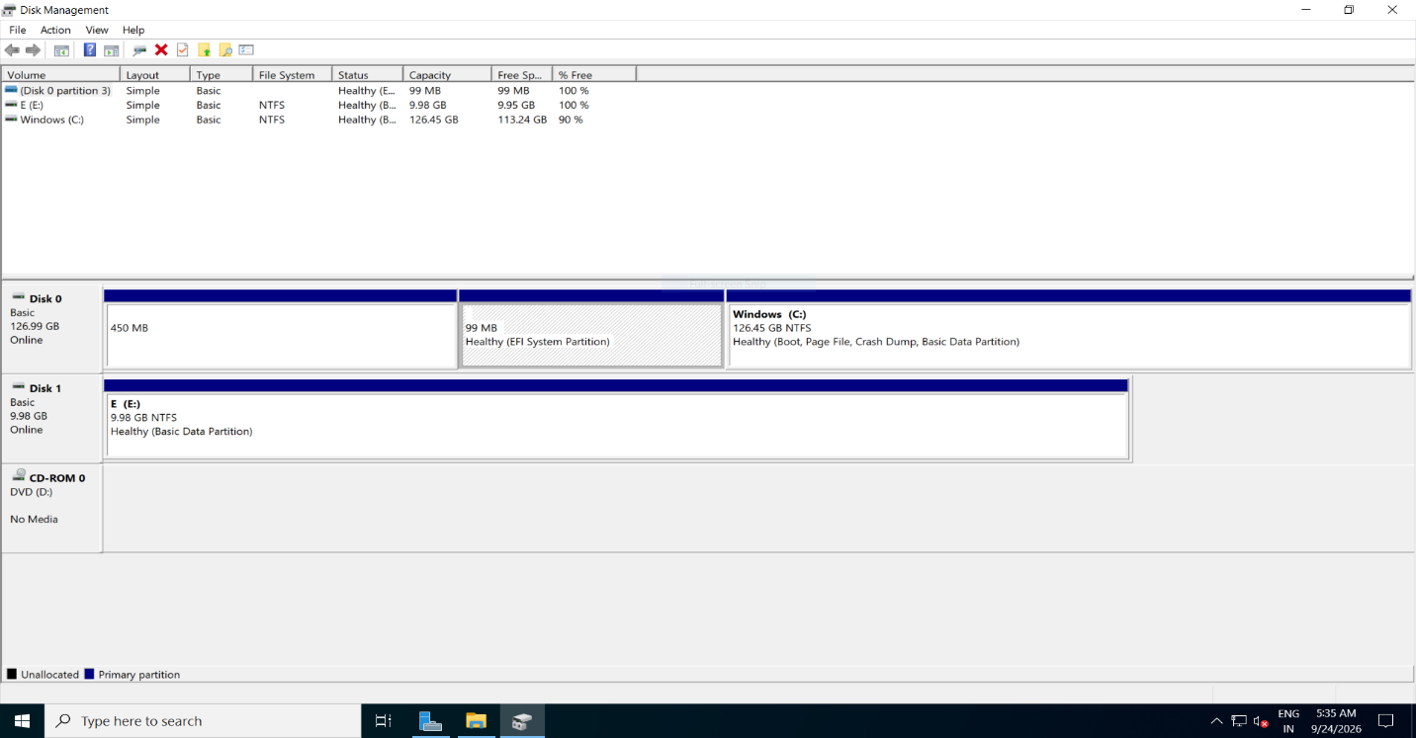

Step 12: Detach the Disk
Navigate to Azure Portal → VM → Disks, remove the data disk, and save the configuration.
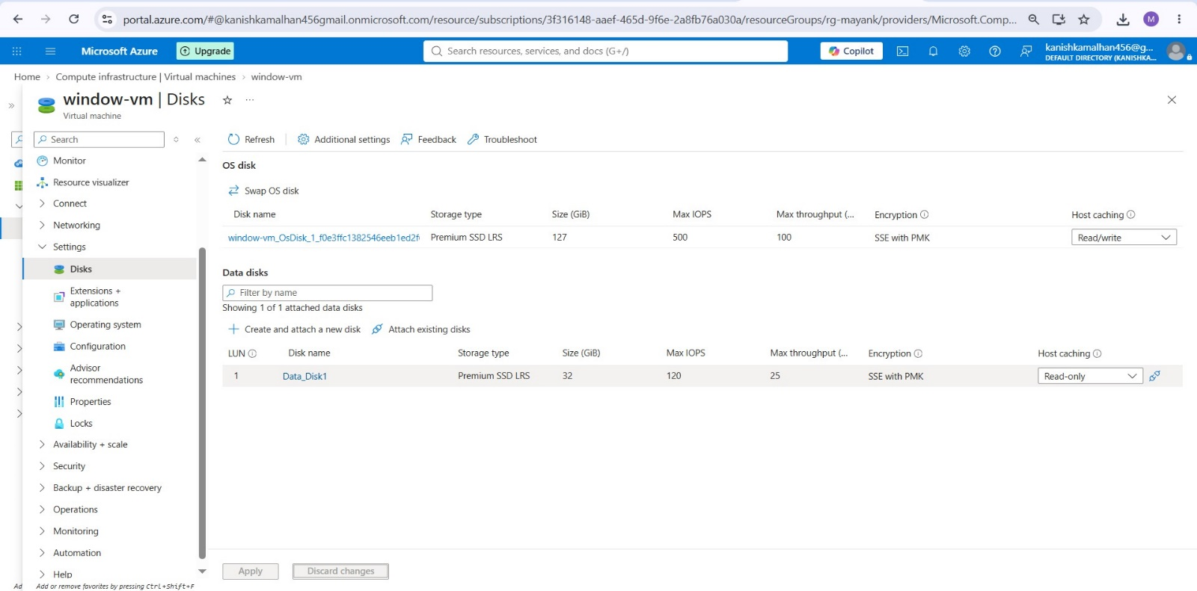

Step 12: Verify Disk is Detached

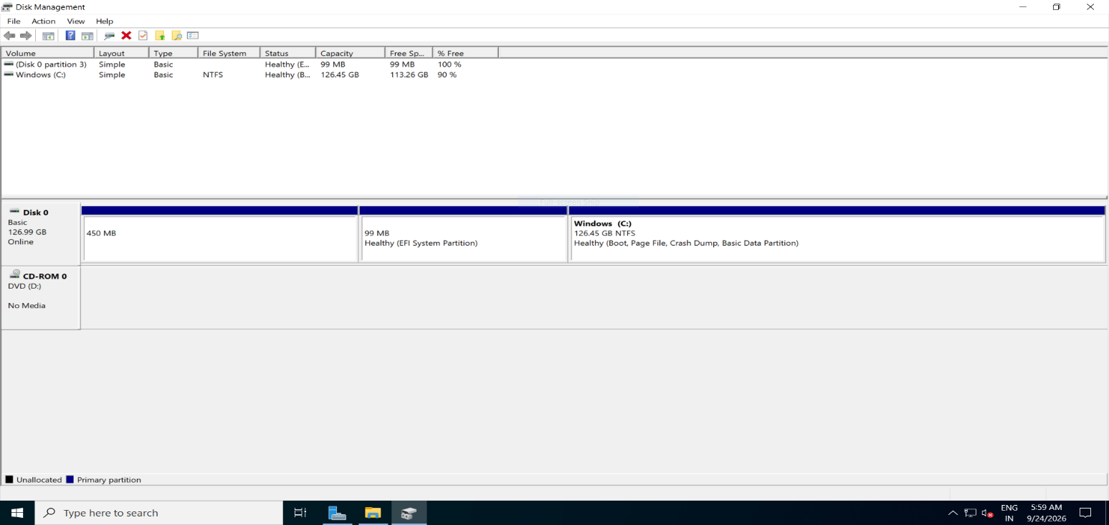

Observation
- Successfully attached a new Azure Managed Data Disk to the Windows Virtual Machine.
- Verified that the newly attached disk was visible in Disk Management.
- Initialized the disk using the GPT (GUID Partition Table) partition style.
- Created a New Simple Volume on the attached disk.
- Formatted the volume using the NTFS file system.
- Assigned the drive letter E: to the volume.
- Verified that the disk was automatically mounted and accessible through File Explorer/Disk Management.
- Confirmed that the disk was available for data storage and usage.
- Successfully detached the data disk from the virtual machine through the Azure Portal.
- Verified that the detached disk was no longer associated with the Windows Virtual Machine.

Result
The Azure Managed Data Disk was successfully attached to the Windows Virtual Machine, initialized, formatted, mounted using drive letter E:, verified for use, and detached successfully from the Virtual Machine.

Attach and Detach a Data Disk to a Linux Virtual Machine

Objective
To attach an Azure Managed Data Disk to a Linux Virtual Machine, verify the disk within the Linux operating system, create a file system, mount the disk for use, validate read/write operations, and safely detach the disk from the virtual machine.

Theory
Azure Managed Disks are block-level storage volumes managed by Microsoft Azure and used with Virtual Machines. A Data Disk provides additional storage capacity beyond the operating system disk and can be attached or detached as per business requirements.
In Linux, a newly attached disk must be formatted with a file system and mounted to a directory before it can be used for storing data. Before detaching a disk, it should be unmounted to prevent data corruption and ensure safe removal.

Components Used
- Microsoft Azure Portal
- Azure Linux Virtual Machine (Linux-vm)
- Azure Managed Data Disk
- Ubuntu 24.04 Operating System
- SSH Terminal

Procedure

Step 1: Open the Linux Virtual Machine
- Sign in to the Azure Portal.
- Navigate to Virtual Machines.
- Select the virtual machine named Linux-vm.
- Verify that the VM is running successfully.
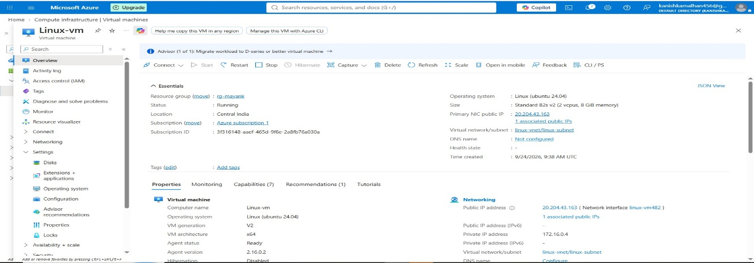

Step 2: Open Disk Settings
- From the left navigation pane, under Settings, click Disks.
- Review the currently attached disks.
- Verify that only the OS disk is attached.

Existing Disk Details
- OS Disk: Linux-vm_OsDisk
- Storage Type: Premium SSD LRS
- Disk Size: 30 GiB
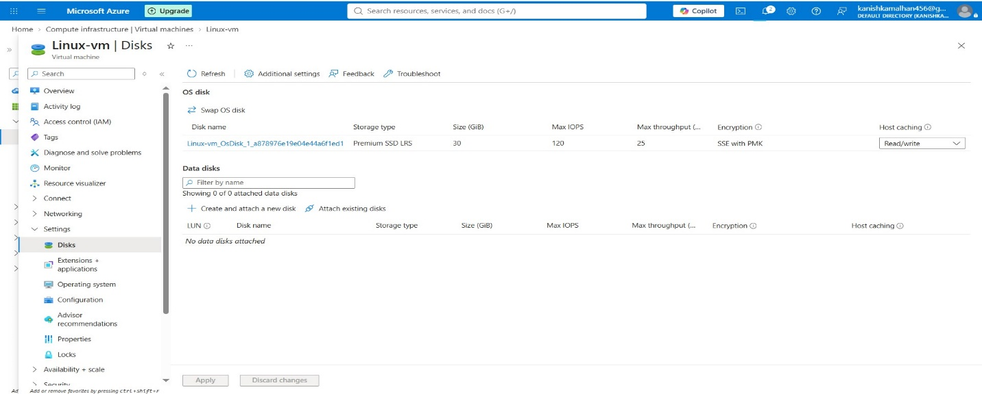

Step 3: Create and Attach a New Data Disk
- Under Data Disks, click Create and attach a new disk.
- Enter the disk name as Data_Disk_1.
- Select Premium SSD LRS as the storage type.
- Specify the desired disk size.
- Click Apply.

New Disk Details
- Disk Name: Data_Disk_1
- Storage Type: Premium SSD LRS
- Encryption: Platform Managed Key
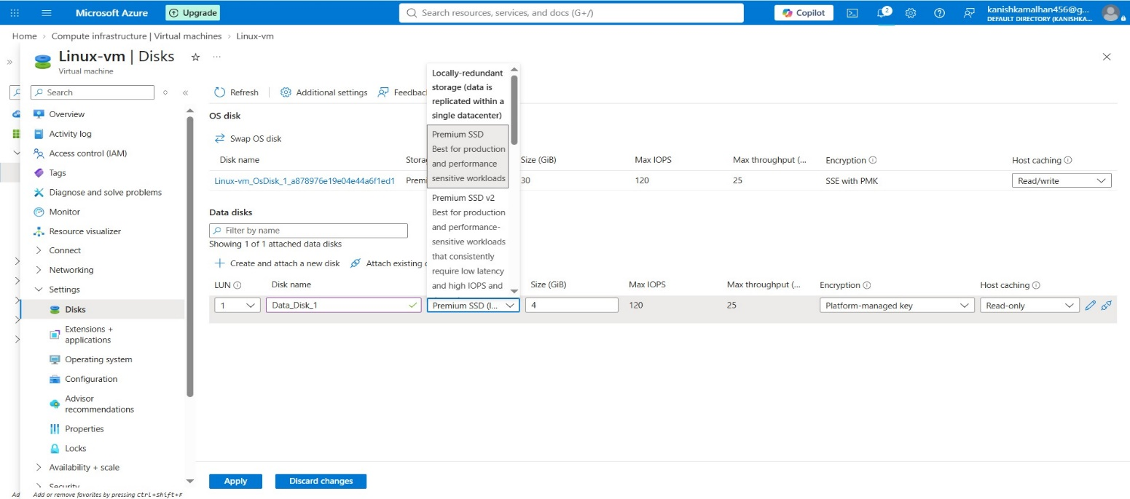

Step 4: Verify Disk Attachment
- Refresh the Disks page.
- Confirm that Data_Disk_1 appears under the Data Disks section.
- Verify that the disk is successfully attached.

Attached Disk Details
- Disk Name: Data_Disk_1
- Storage Type: Premium SSD LRS
- Disk Size: 8 GiB
- Host Caching: Read-only
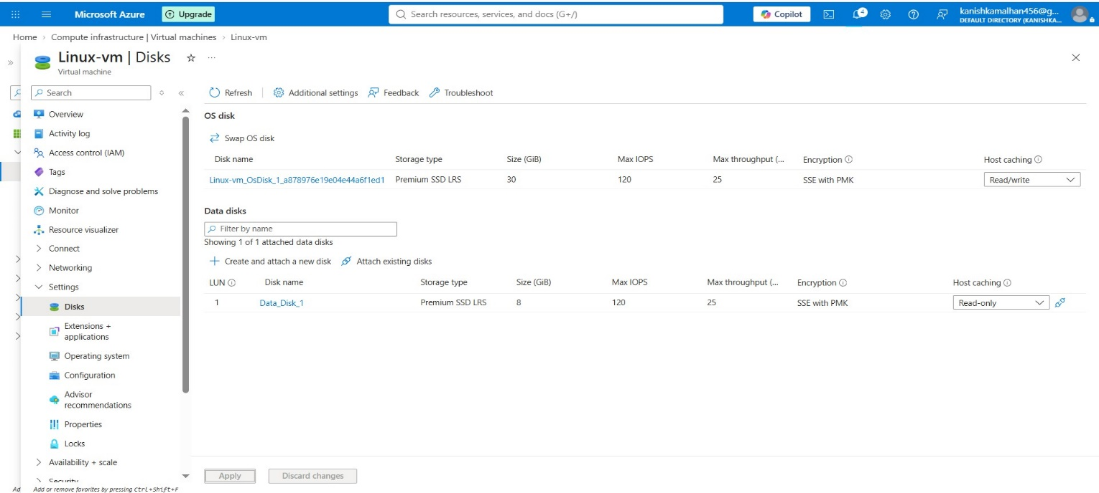

Step 5: Connect to the Linux Virtual Machine
- Open the SSH terminal.
- Connect to the Linux VM using the VM's Public IP Address.
- Verify successful login.
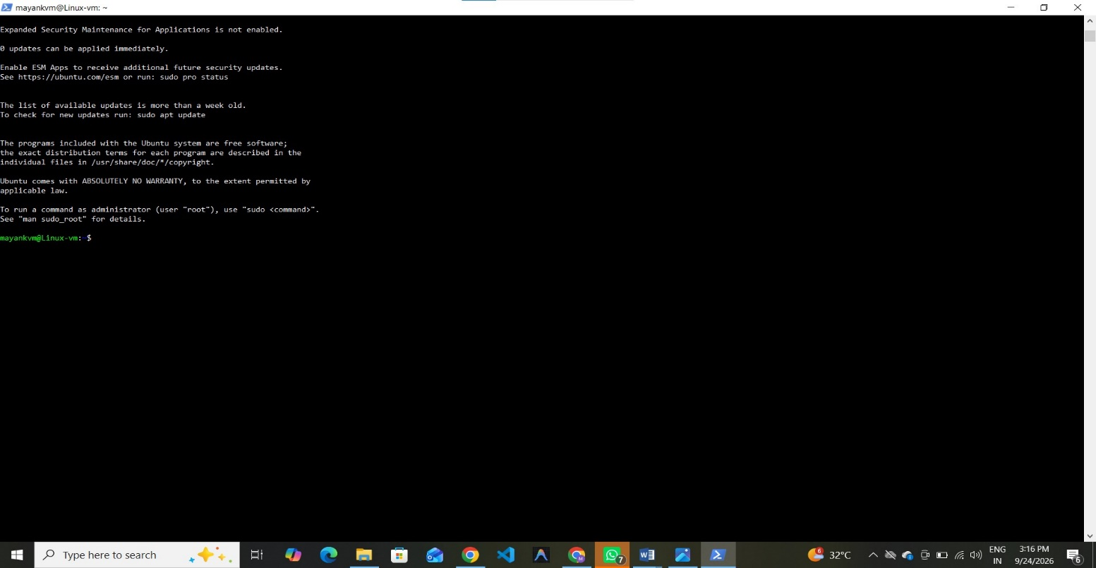

Step 6: Verify the Newly Attached Disk
- Execute the following command:
- lsblk
- Review the available block devices.
- Verify that a new disk sdb appears in the output.

Observation
- sda represents the operating system disk.
- sdb represents the newly attached data disk.
- The size of the new disk is 8 GiB.
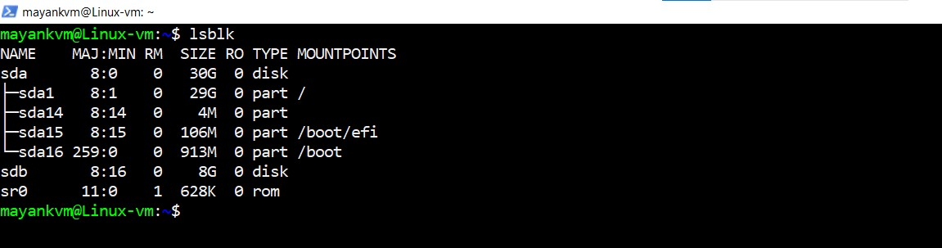

Step 7: Format the Data Disk
- Create an EXT4 file system on the newly attached disk using the following command:
- sudo mkfs.ext4 /dev/sdb

Purpose
Formatting prepares the disk for storing files and directories by creating a Linux-compatible file system.
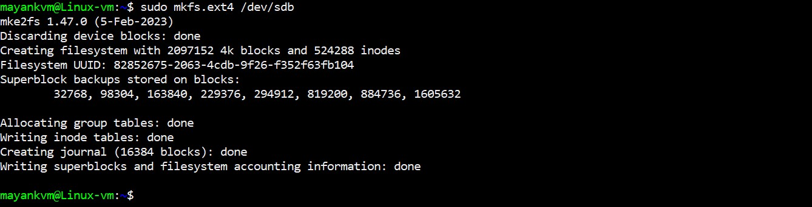

Step 8: Create a Mount Point and Mount the Disk
Create a directory to use as a mount point:
- sudo mkdir /datadisk
Mount the disk to the directory:
- sudo mount /dev/sdb /datadisk
Verify the mount status:
- df -h

Observation
- Disk /dev/sdb is mounted successfully.
- Mount Point: /datadisk
- Available Space: Approximately 8 GB
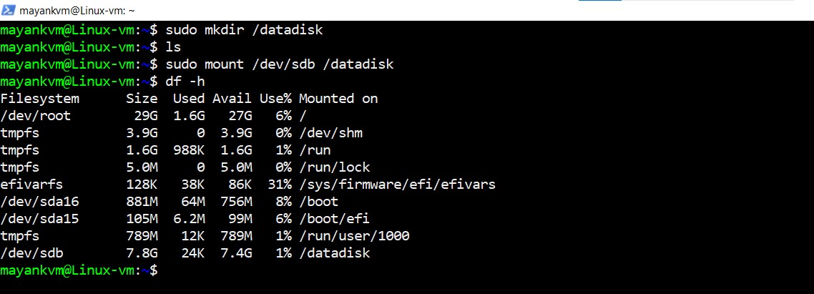

Step 9: Verify Read and Write Access
Navigate to the mounted directory:
- cd /datadisk
Create a test file:
- sudo touch mayank
List the files:
- ls
Verify that the file has been created successfully.

Observation
- Folder Present: lost+found
- Test File Created: mayank
- Disk is operational and writable.
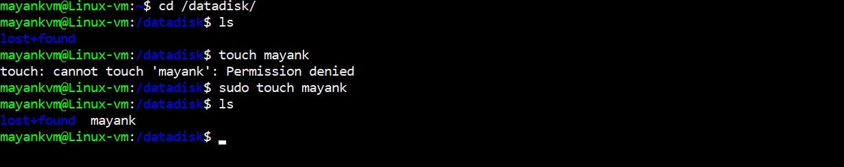

Step 10: Unmount the Data Disk
Move outside the mounted directory:
- cd ..
Unmount the disk:
- sudo umount /datadisk
Verify using:
- df -h
Confirm that /datadisk is no longer displayed.
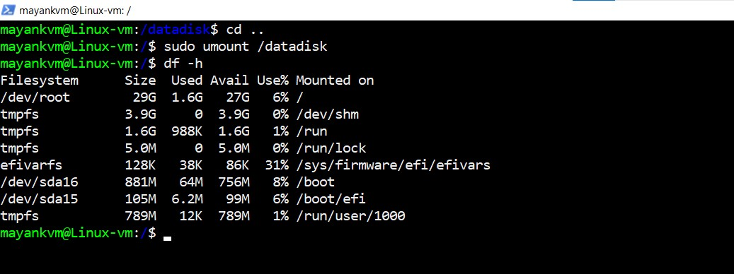

Step 11: Detach the Data Disk
- Return to the Azure Portal.
- Open VM → Disks.
- Select the attached Data Disk.
- Click Detach Disk.
- Save the configuration.
- Refresh the page and verify that no Data Disk is attached.
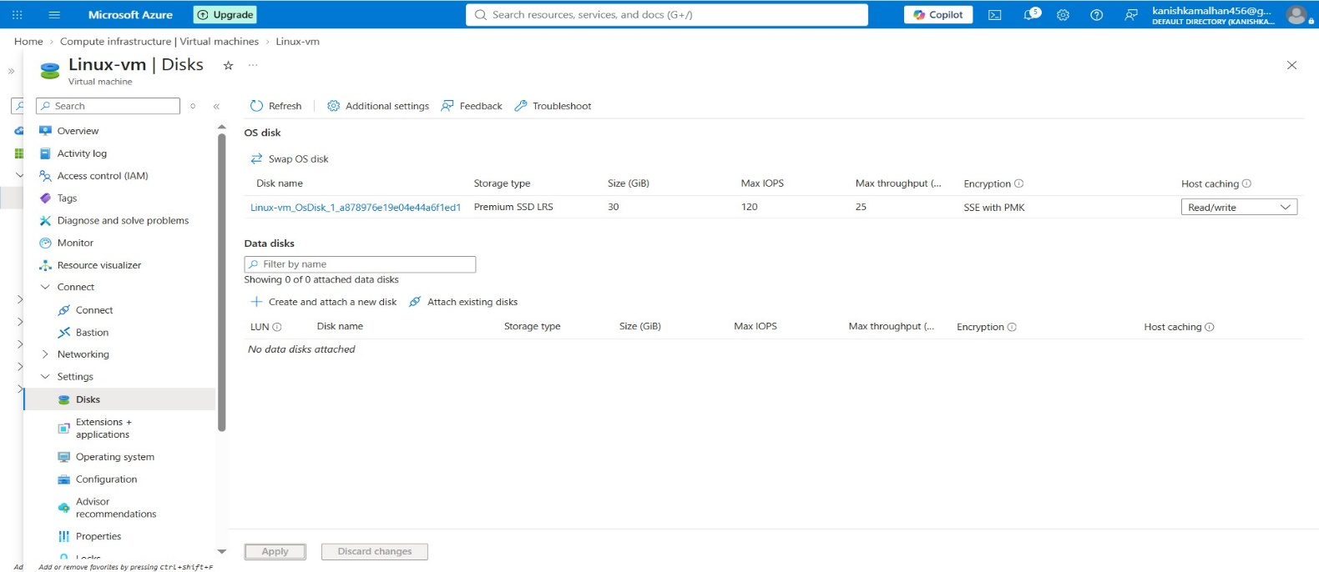

Step 12: Verify Disk Removal
- Return to the SSH session.
- Execute:
- lsblk
Verify that only the operating system disk remains.

Observation
- sdb is no longer displayed.
- The data disk has been detached successfully.
- Only OS disk sda remains attached.
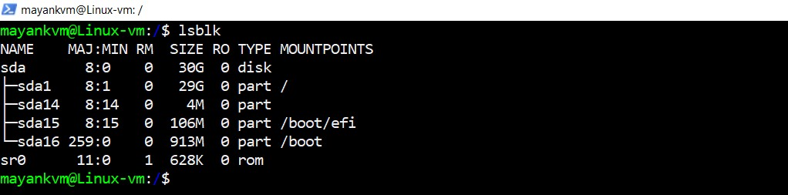

Observation
A managed data disk was successfully attached to the Linux Virtual Machine, detected by the operating system, formatted using the EXT4 file system, mounted for use, and verified through file creation. The disk was then safely unmounted and detached from the VM without impacting the operating system disk.

Result
The Azure Managed Data Disk was successfully attached, verified, formatted, mounted, tested, unmounted, and detached from the Linux Virtual Machine.

